1) In Khelo India youth games 2019 photo gallery page footer is not in the bottom of the page
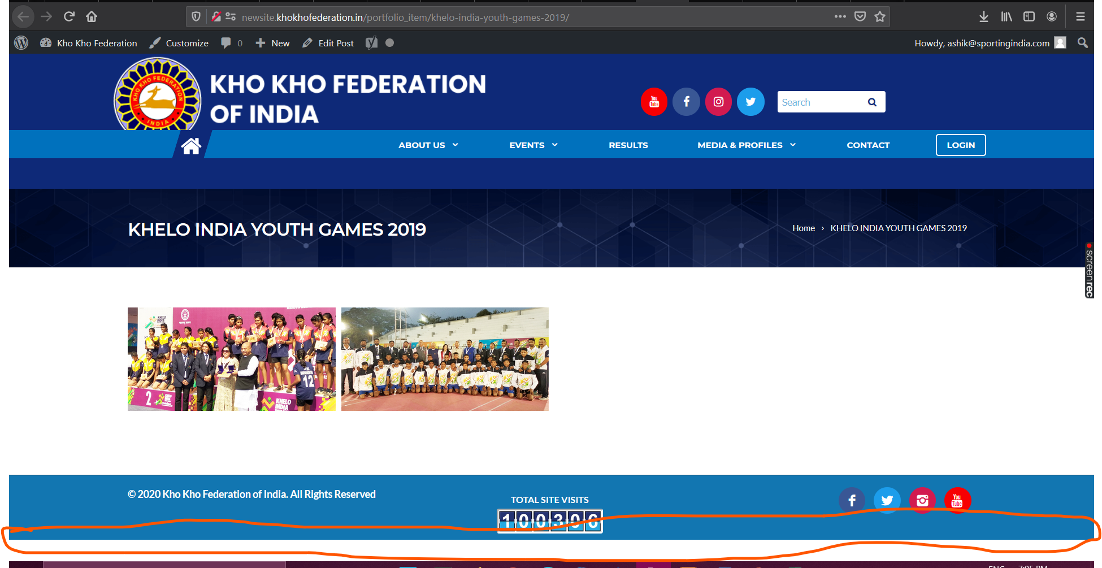
2) There is no Total Visit Count in the mobile view
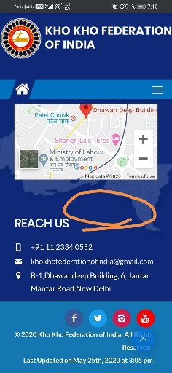
3) In Footer There is no Map & Address in the inner pages of photo gallery
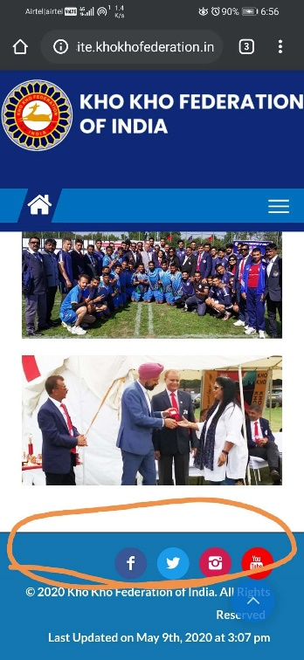
4) IN State associations page for Goa, Madhya Pradesh, Odisha, Punjab, Uttarakhand, West Bengal, Mail id’s alignment is missing
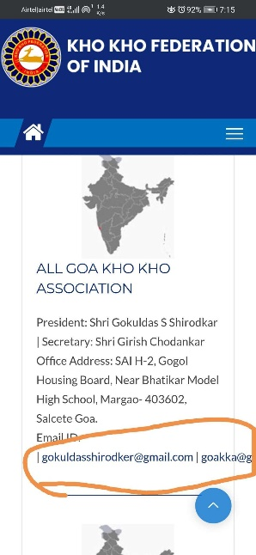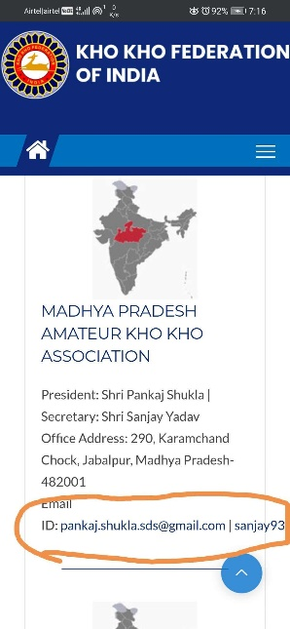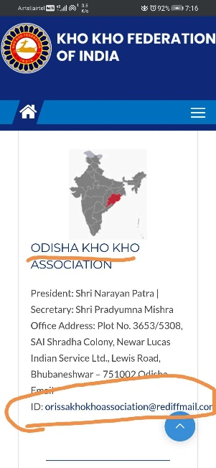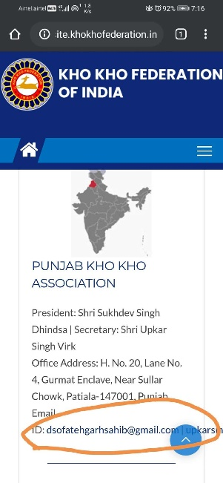

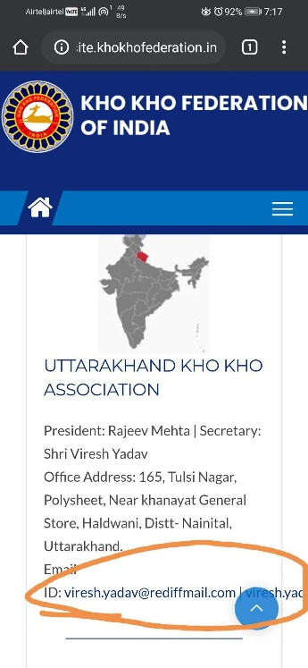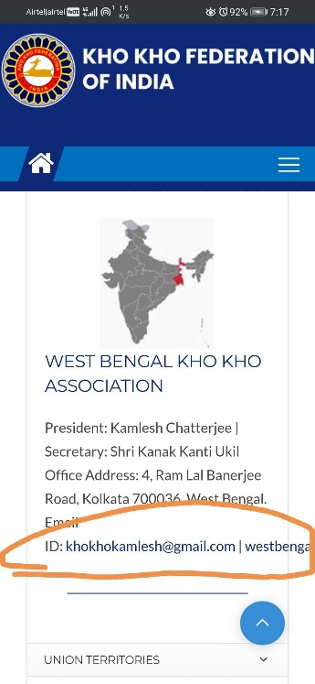

5) In State Associations & Affiliated Units page Border Security Force, Railway Sports, Vidarbha, Kolhapur, alignment is missing and image should be placed in the right place
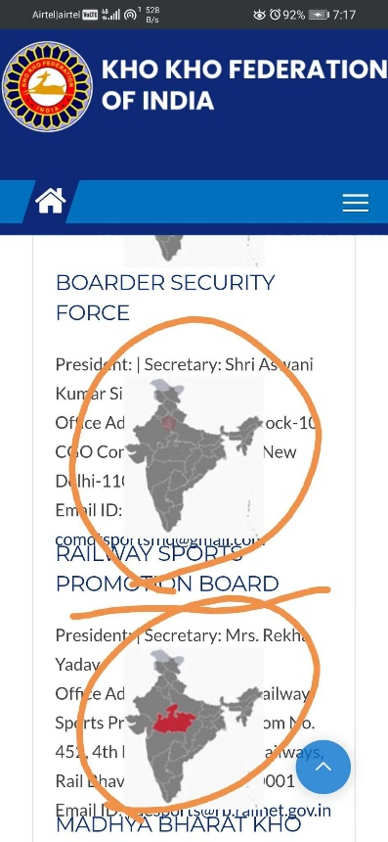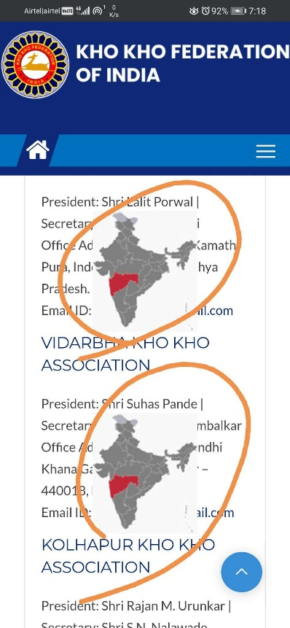
6) In Circular Close button is overlapping for 4th & 7th circular
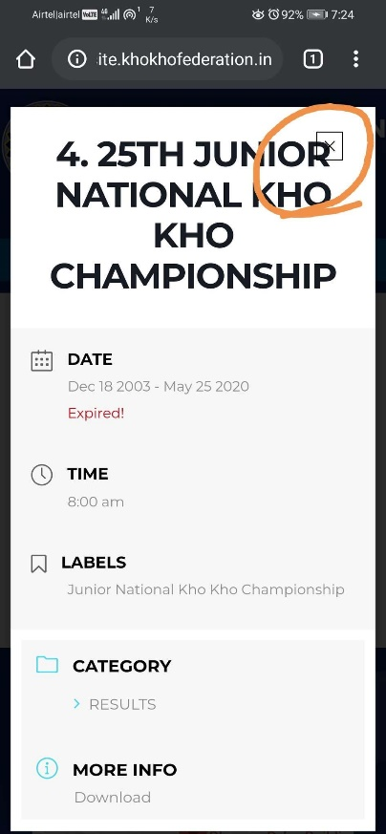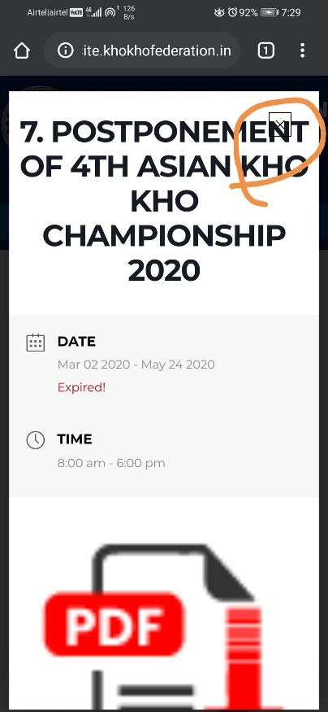

7) in De - Affiliation of Kerala Kho Kho association circular image issue below the PDF Icon
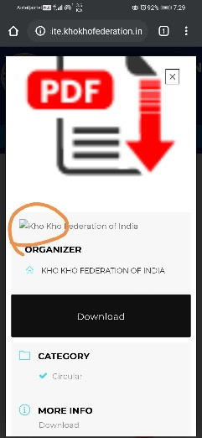
8) In Contact Us Page After submitting the subscription the message in the subscription box is not visible
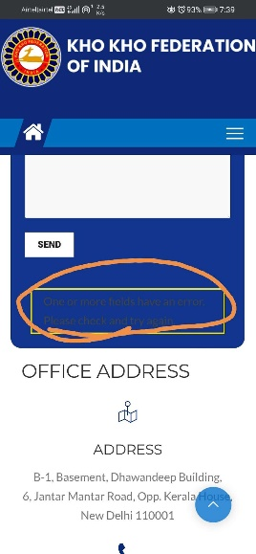
9) In mobile responsive after clicking on the menu icon it’s overlapping the header
